Art review: ‘Thinking Large, Working Small’ is rock-solid exhibit at Summit Artspace
Anderson Turner
Special to Akron Beacon Journal
View Comments
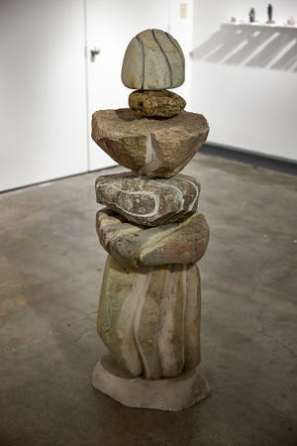
The process of making art is often one of the greatest mysteries for anyone studying the work of any particular artist. The who, where, when, why and how of art making can be elusive and sometime indiscernible even if you have the chance to ask an artist directly.
This is why you will find exhibits dedicated to studies and drawings by hugely famous artists from history like Michelangelo or Cézanne even when the artist never intended this part of their work or process to be shown in a gallery or museum.
More:Art review: Summit Artspace juried exhibit is more ‘FRESH’ than usual
“Thinking Large, Working Small,” an exhibit on display through March 26 in the 3G Gallery on the third floor of Summit Artspace, is a fun, fascinating look into the studio practice of Kenn Hetzel. The exhibit consists of 100 small-scale stone sculptures that also act as maquettes for large-scale pieces that “may or may not” be constructed.
After visiting the sculpture gardens at Storm King Art Center in New Windsor, New York, and the studio and sculpture gardens of Chuck Herndon on Kelleys Island, Hetzel was inspired to combine aspects of both in a series of works. From 2017 to 2020, he created the 100 sculptures.
“Inspiration for my works varies greatly as does the sculptures themselves,” Hetzel notes in his artist’s statement.
The works are largely constructed out of stone. However, the stone is frequently combined with metal, wood and found objects, which helps keep the viewer’s eyes moving around the room.
Also engaging is the manner in which the sculptures are displayed.
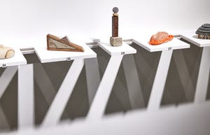
The artist created an unusual system of shelves on a small railing that runs around the perimeter of the gallery. Each shelf has a work on it and a corresponding number from one to 100. The size of each shelf appears to correspond with the work as some are smaller while others are longer, depending on what is placed on them.
The different shelving sizes helps to create a rhythm to the display and makes it easier to engage with the work the more you investigate the sculptures.
In the center of the room are two larger stone and steel sculptures inspired by the 100 smaller pieces.
“Sculpture 1,” as it's called, features a stack of different-sized boulders that have been carved into. This piece is akin to Buddhist stacking stones where different shaped rocks are stacked onto each other with each layer representing a different wish of the person making the stack.
Your stories live here.
Fuel your hometown passion and plug into the stories that define it.
Create Account
“Sculpture 2” features a rectangular stone column with a carved, abstract, lighter shade of stone stacked on top of it. On top of the lighter stone element is a rusty slice of what could be metal pipe. Despite the obvious weight and forces of gravity working on the elements in this sculpture, it is still an expressive work that appears to defy gravity a little bit as it commands you to look at it.
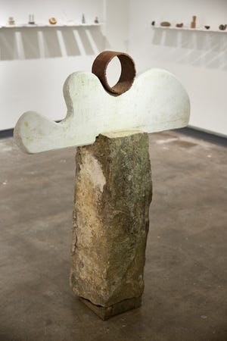
The 100 maquettes that line the outer walls of the gallery feature many different and interesting works. It’s thought-provoking to walk through the gallery to see which pieces you react to the most.
“Number 85” is a mixed media work that features a triangular stone that has been outlined/encased in wood. On the longest part of the right triangle or the hypotenuse sits another smaller triangular piece of stone that is attached by a tiny piece of cabled wire to the top of the larger element.
This sculpture features a lot of gravity-induced tension for an object that is fairly tiny, 2.25 inches tall by 5 inches wide by 0.75 inch in diameter. This is also a finished-looking work or “complete” thought that it is easy to ponder the sculpture re-created in a much larger scale.
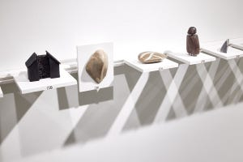
What is perhaps most compelling about this exhibit is how the artist has created not just 100 small maquettes with two larger works, but how the artist has created moments of clarity and contemplation inside such a confined space. You really get to take a ride with Hetzel if you choose, and it is an intense and deep dive into the point of creation and completion for each work. This can only be inspiring.
“Thinking Large, Working Small” is an exhibit by an artist who has chosen to highlight and even emphasize his studio practice and some of the processes he goes through when working on sculptures.
This is an exhibit that draws you in and draws you back to see it the more time you spend with the work. It’s worthy of a visit to Summit Artspace.
Details
Exhibit: “Thinking Large, Working Small” by Kenn Hetzel
Place: 3G Gallery at Summit Artspace, 140 E. Market St., Akron
Hours: Noon to 7 p.m. Fridays and 11 a.m. to 5 p.m. Saturdays through March 26
More info: https://www.summitartspace.org or 330-376-8480
More:Art review: ‘Surreal by Nature’ exhibit is beautifully creepy at Akron Soul Train
More:Art review: Alex Ross exhibit of comic-book heroes is truly marvelous
View Comments

